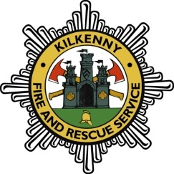 | CHIEF FIRE  OFFICERS ASSOCIATION  Annual Conference  KILKENNY 2022  DAY 1 – WEDNESDAY 4th MAY 2022 | 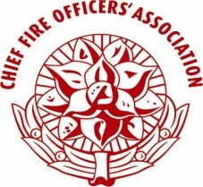
Session 1 | Chairperson: Mr. Adrian Kelly, CFO, Clare Co. Co.
09:15-09:25 | Opening address  Minister Darragh O'Brien, TD for Housing, Local Government and Heritage
09:25-09:35 | Address of Welcome:  Cathaoirleach of Kilkenny County Council, Councillor Ms. Fidelis Doherty
09:35-09:45 | Address of Chief Executive:  Ms Colette Byrne, Chief Executive, Kilkenny County Council
09:45-10:10 | Chairperson’s Address:  Ms Celina Barrett, Chief Fire Officer, Kildare Co Co  Chairperson of the Chief Fire Officers Association
10:10-10:45 | “Leadership in sport – lessons for the fire service”  Brian Cody- Manager of Kilkenny Senior Hurling Team
10:45-10:55 | Tech Talk 1 – Telent
10:55-12:30 | Trade Show & Coffee – Exhibitors Hall
12:30-14:00 | Lunch
Session 2 | Chairperson: Mr. Gerry O’Malley,CFO, Galway Co. Co.
14:00-14:45 | Safety Leadership -Joining the dots bottom up – Connecting our purpose to process  Maeve O ‘Loughlin, Implementation Lead ,A.P. Moller - Maersk
14:45-14:55 | Tech Talk 2 – TBC
14:55-15:45 | Trade Show & Coffee – Exhibition Hall
15:45-16:30 | Leadership- Building resilience in your staff  Susan Hayes Culleton, CFA- Hayes Culleton Group,
16:30-17:00 | Panel Discussion
20:00 | CHIEF FIRE OFFICERS’ ASSOCIATION ANNUAL GALA DINNER (BLACK TIE)  In Mount Juliet Estate, Thomastown ,Co Kilkenny

 | CHIEF FIRE  OFFICERS ASSOCIATION  Annual Conference  KILKENNY2022  DAY 2 – THURSDAY 5TH MAY 2022 | 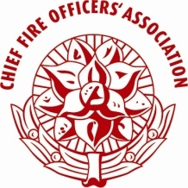
Session 3 | Chairperson: Mr. Seamus Coughlan, CFO , Cork Co. Co.
09:30-10:10 | “ How do you fight a fire you can’t find?- The Ocado Fire”  Shantha Dickinson, Deputy Chief Fire Officer, Hampshire Fire & Rescue Service, UK
10:10 -10:45 | “ Strategic overview of the Fire Services in Ireland – A National Directorate perspective  Mr. John Mc Carthy, Chairperson of  National Directorate for Fire & Emergency Management Board, Ireland
10:45-11:15 | Smart Cities & Smart Fire Services  Bert Brugghemans, Chief Fire Officer of Antwerp Fire Service, Belgium
11:15-11:25 | Tech Talk 3 – Sioen Ireland
11:25-12:30 | Trade Show & Coffee – Exhibitors Hall
12:30-14:00 | Lunch & Trade Show
Session 4 | Chairperson: Mr. Dennis Keeley, CFO, Dublin Fire Brigade
14:00-14:45 | Strategic Planning for Stress Management and Critical Incident Stress Management in the Workplace”  – Patricia Murray, Health and Safety Authority, Ireland
14:45-15:30 | Leadership in the Fire and Rescue Service – Current projects – NFCC leadership Framework  Mark Hardingham Chair of the National Fire Chiefs Council (NFCC) UK
15:30-16:15 | “Fire Service Recruitment and Retention”  Karin Dangermond MSc MA, Researcher at Netherlands Institute for Public Safety
16:15-17:00 | Panel Discussion & Closing Summary

